SKR & SKR GOVERNMENT COLLEGE FOR WOMEN [ A ], KADAPA
2.3.2 Teachers use ICT enabled tools including online resources for effective teaching and learning process.
PRINCIPAL | Name: Dr P.Subba Lakshumma  M.Com., M.Phil., Ph.D.  Designation: Principal  Programme: III B.Com CA VI SEM  Course Title:  Topic: Ratio Analysis  Learning Outcome: Students are able to understand Ratio Analysis and analyse the Short-term and  Long-term Financial capacity of a company by using ratios.  Teaching pedagogy: Participatory Learning and Problem Solving. | 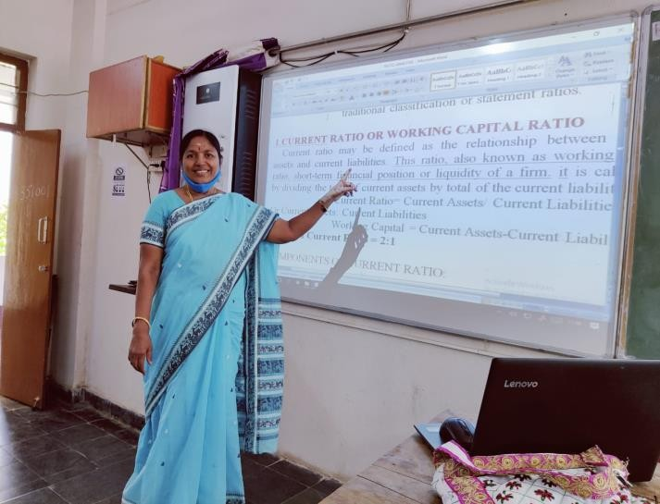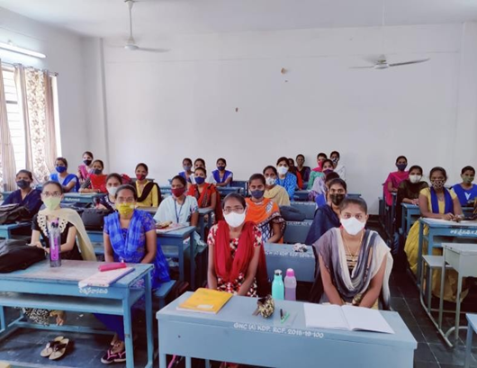
 | 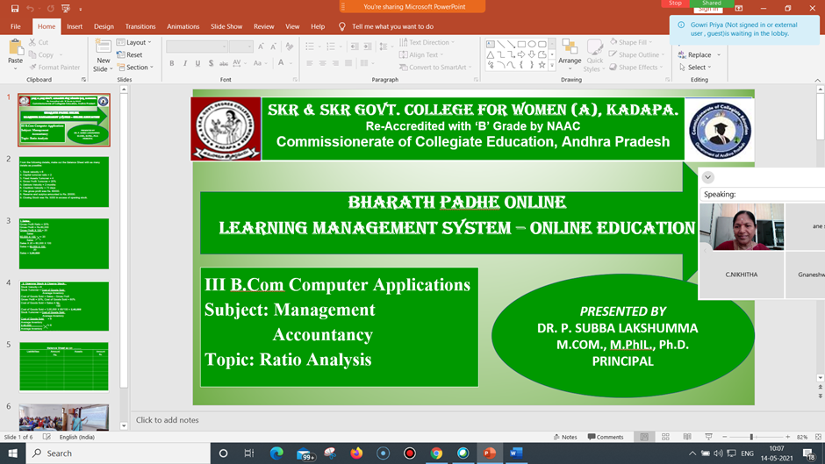
Commerce | NAME : V.SREE RAMA REDDY  DESIGNATION : Lecturer in Commerce  TOPIC : Meaning , definition & objectives of management accounting  Cos/LEARNING OBJECTIVEs : To know how to prepare and submit the essence of raw data  TEACHING METHODS ADOPTED : participative learning (PPT)  GROUP/SEMESTER : III.BCOM (TM), VI semester  APPLICATION :Critical analysis and understanding the data | 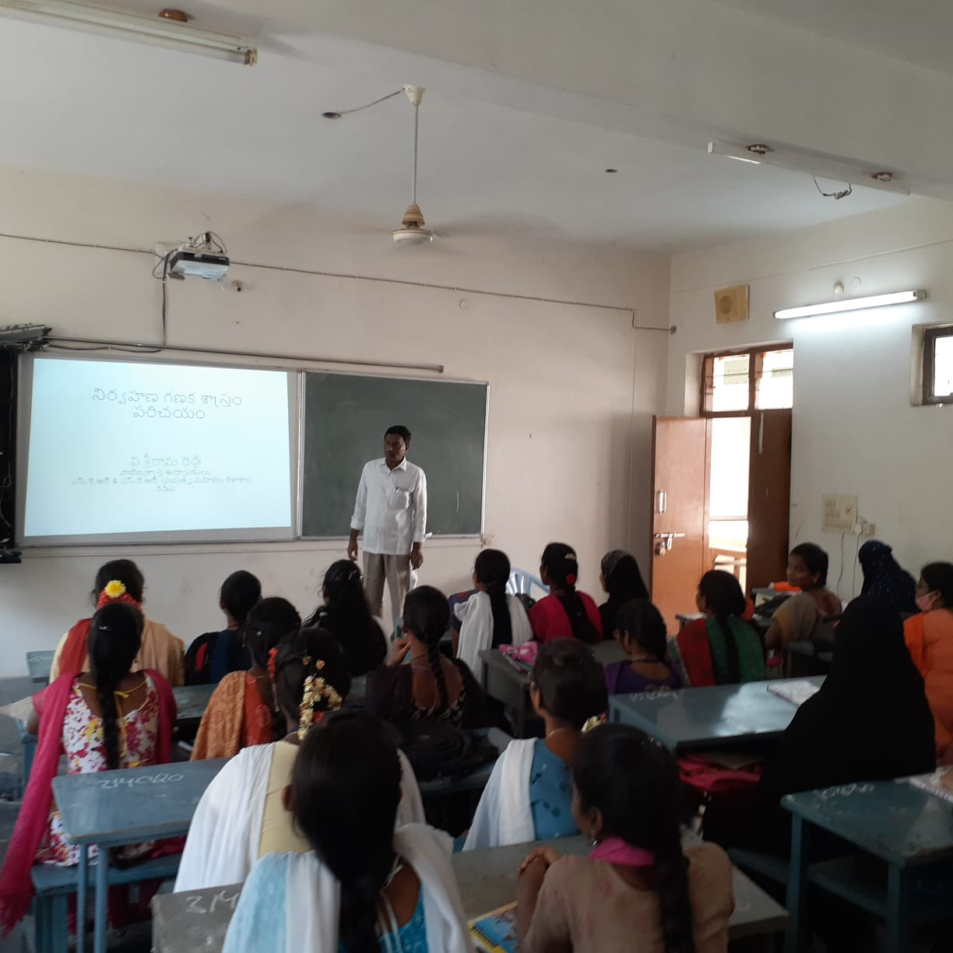
 | NAME : O.KHAJA MOHIDEEN  DESIGNATION : Lecturer in Commerce  TOPIC : Principles of Accounting  Cos/LEARNING OBJECTIVES : To know Accounting procedure and recording of financial  Transactions  TEACHING METHODS ADOPTED : Interactive method  GROUP/SEMESTER : I.BCOM (CA),(G) Ist SEMESTER  APPLICATION : Use information support business process and decisions making | 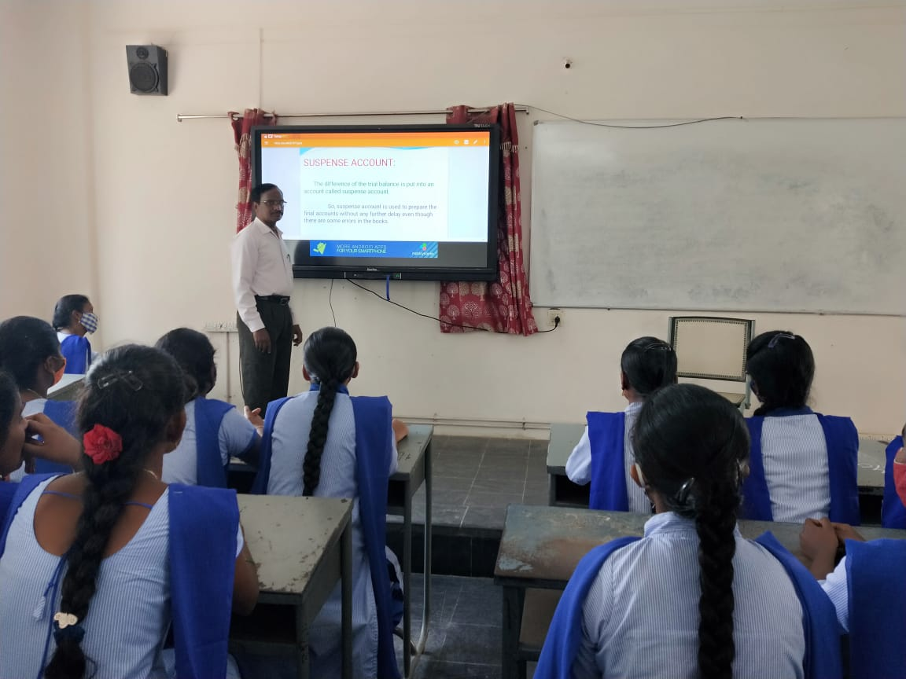
ZOOLOGY | NAME :Mrs.B. Swarna Mary  DESIGNATION : Lecturer in Zoology  TOPIC : Incomplete dominance  Cos/LEARNING OBJECTIVES :  To contrast complete dominance &  Incomplete dominance.  TEACHING METHODS ADOPTED :Participative learning [ PPT]  GROUP/SEMESTER :IIB.Sc{TM) – III SEM  APPLICATION : To study the inheritance pattern. | 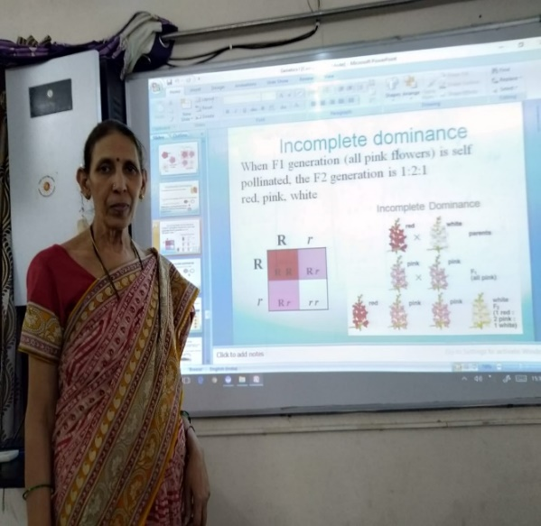
 | NAME :Dr. P. Sachidevi  DESIGNATION : Lecturer in Zoology  TOPIC : Monoclonal Antibodies  Cos/LEARNING OBJECTIVES : To learn about the Hybridoma  Technology.  TEACHING METHODS ADOPTED :Participative learning [ PPT]  GROUP/SEMESTER :III B.Sc{EM) – VI SEM  APPLICATION :Disease diagnosis & treatment. | 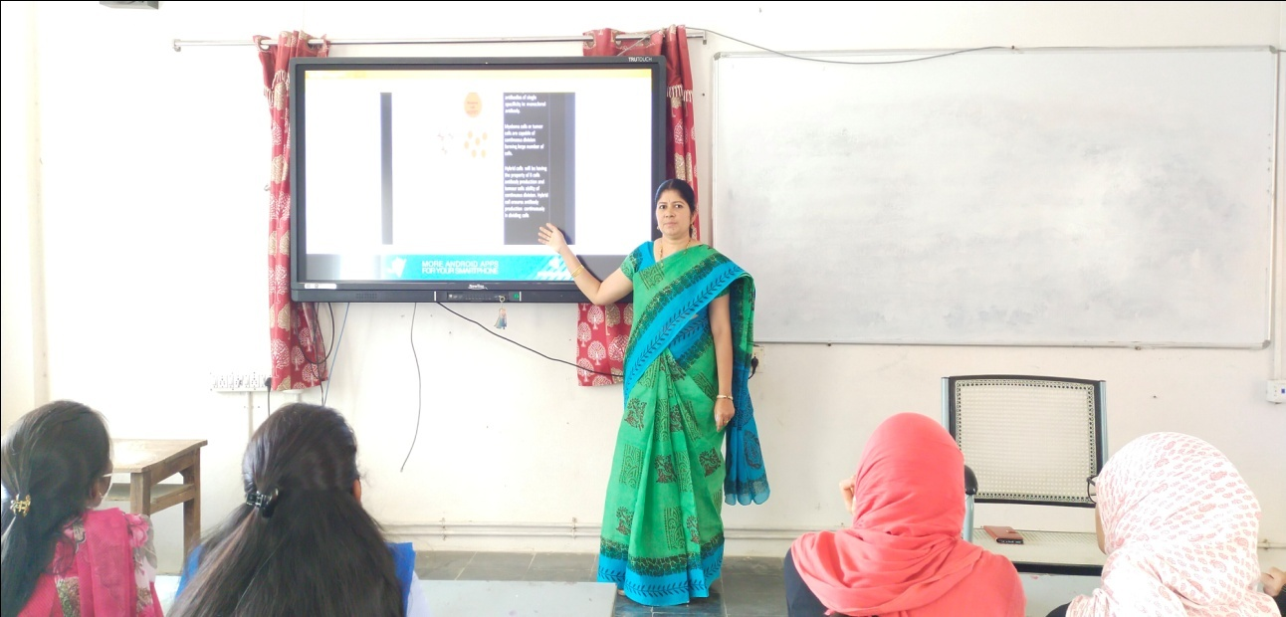
BIOTECHNOLOGY | NAME: S.SivaGowri  DESIGNATION :Guest Lecturer in Bio-Technology  TOPIC : Isolation methods of microorganisms  Cos/LEARNING OBJECTIVES : To learn the isolation of the microorganism from  soil sample.  TEACHING METHODS ADOPTED :Participative learning [ PPT]  GROUP/SEMESTER :IIIB.Sc – VI SEM  APPLICATION : To isolate the microorganisms. | 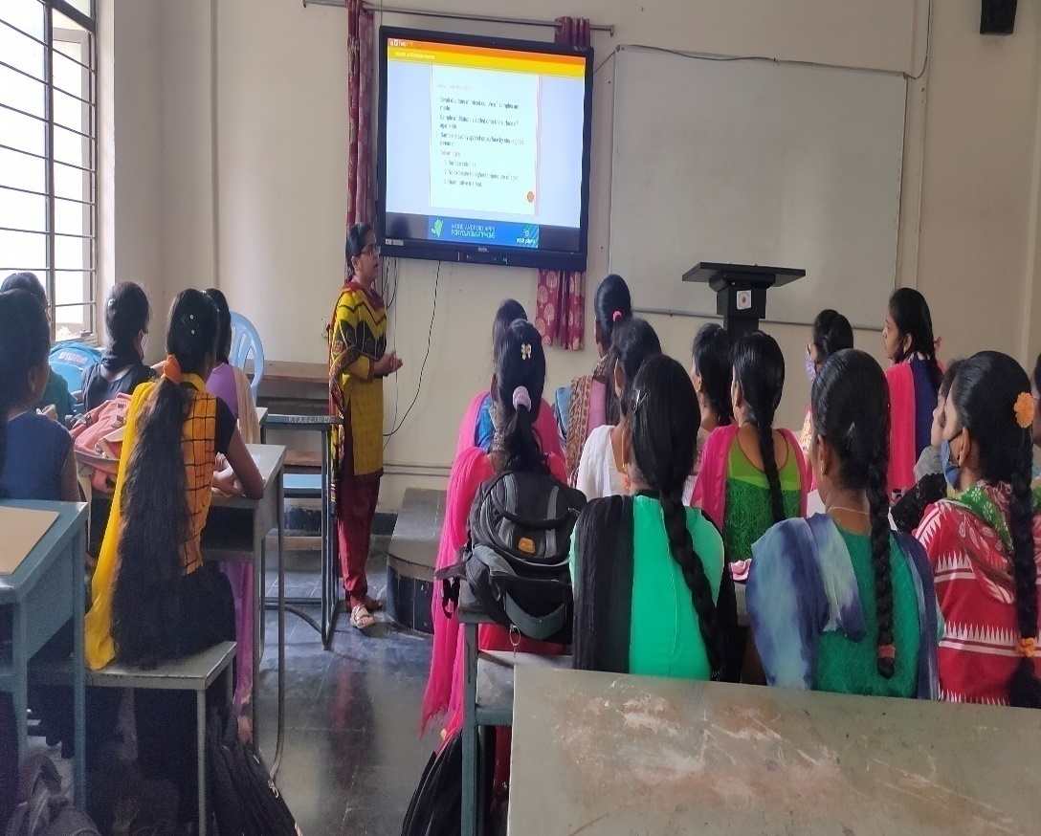
BOTANY | NAME :Dr.P.Subramanyam  DESIGNATION : Lecturer in Botany  TOPIC : Phyto geographical Regions of India  Cos/LEARNING OBJECTIVES : To aware the students towards distribution of Plants &Climatic conditions with relation plant growth  TEACHING METHODS ADOPTED : Participative learning [ PPT]  GROUP/SEMESTER : III B.Sc, B.Z.C {EM ) – V SEM | 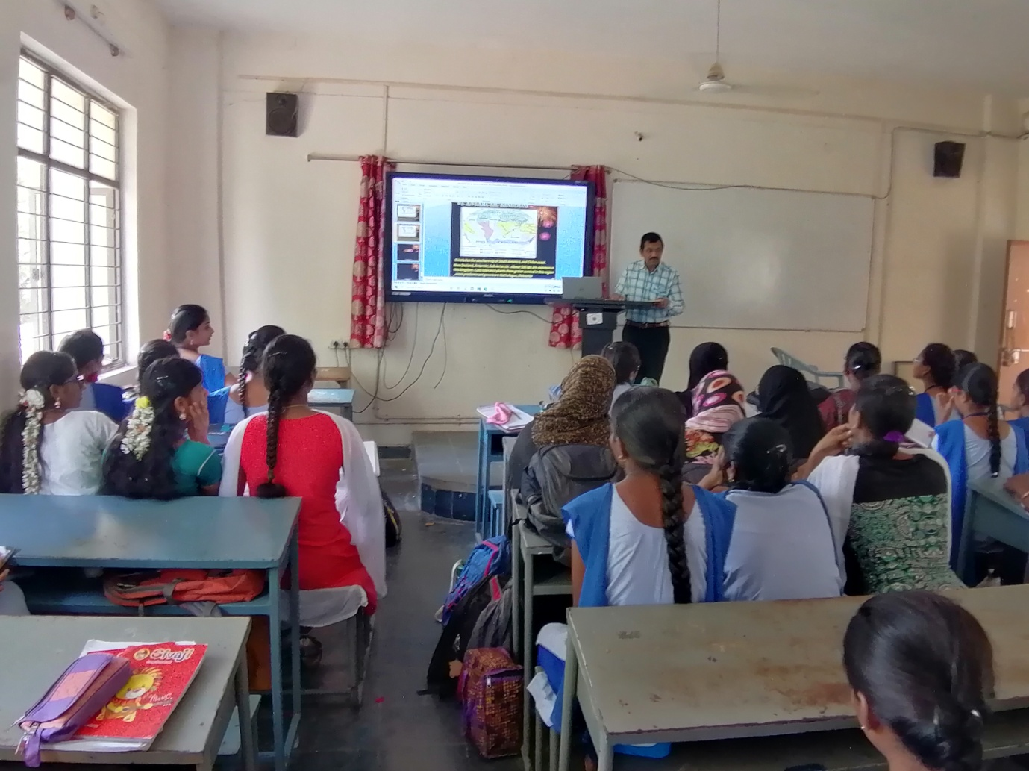
 | NAME :Y.Nagarathanamma  DESIGNATION : Lecturer in Botany  TOPIC : Algae  Cos/LEARNING OBJECTIVES : green algae  TEACHING METHODS ADOPTED : Participative [PPT]  GROUP/SEMESTER : IB.Sc, B.Z.C,BCH (EM) –I SEM  APPLICATION : Students will enrich about algae | 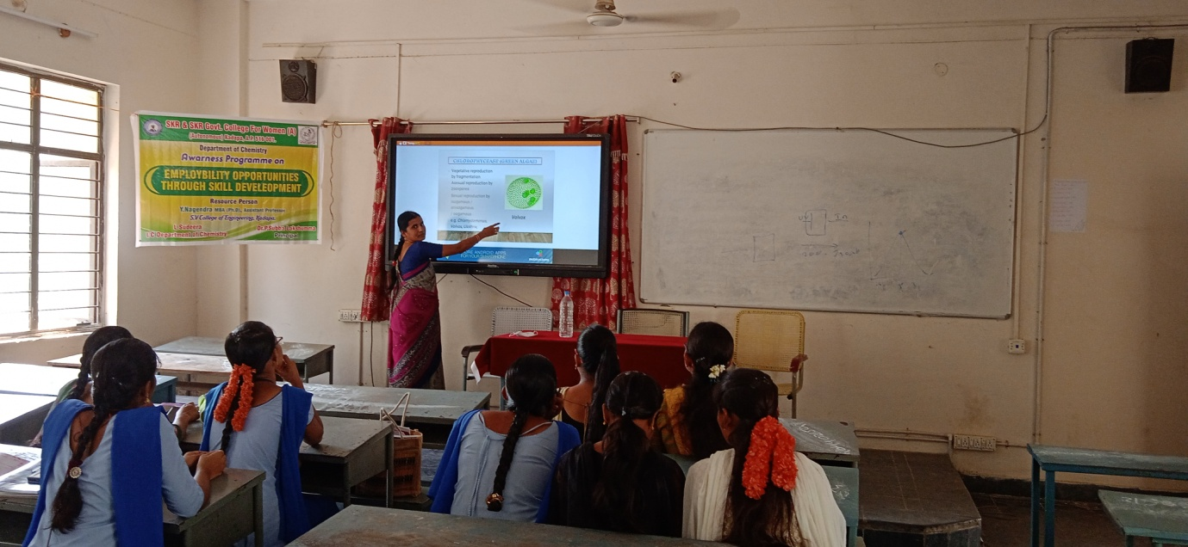
Mathematics | NAME Dr P.Guriv Reddy  DESIGNATION Lecturer in Mathematics  TOPIC vector spaces  Cos/LEARNING OBJECTIVES : To develop analytical knowledge  TEACHING METHODS ADOPTED : Participative [PPT]  GROUP/SEMESTER : III B.Sc MPCs | 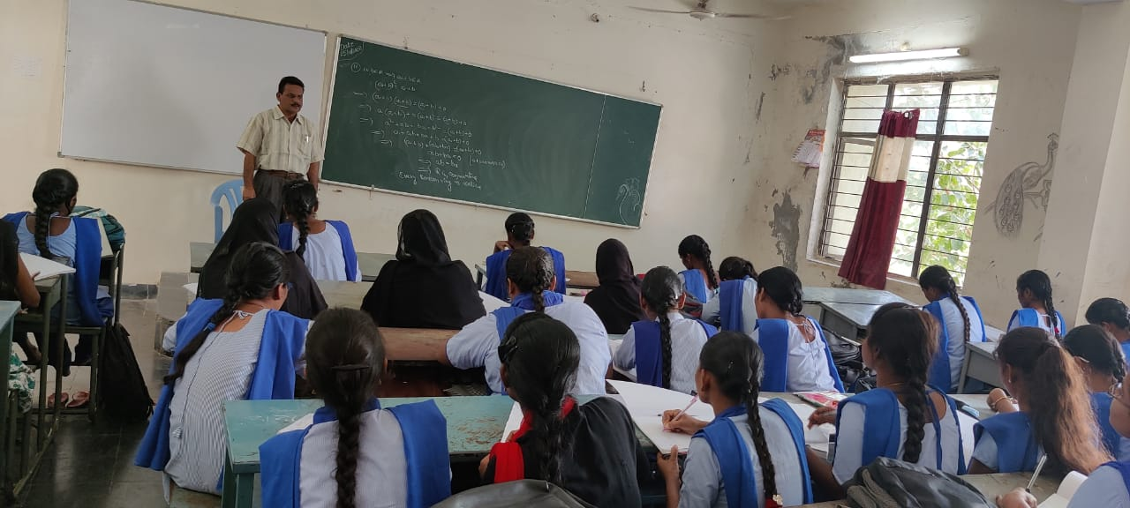
 | NAME K. Shalini  DESIGNATION Lecturer in Mathematics  TOPIC : Ring theory  Cos/LEARNING OBJECTIVES : To develop analytical knowledge  TEACHING METHODS ADOPTED : Participative [PPT]  GROUP/SEMESTER : III B.Sc MSCs | 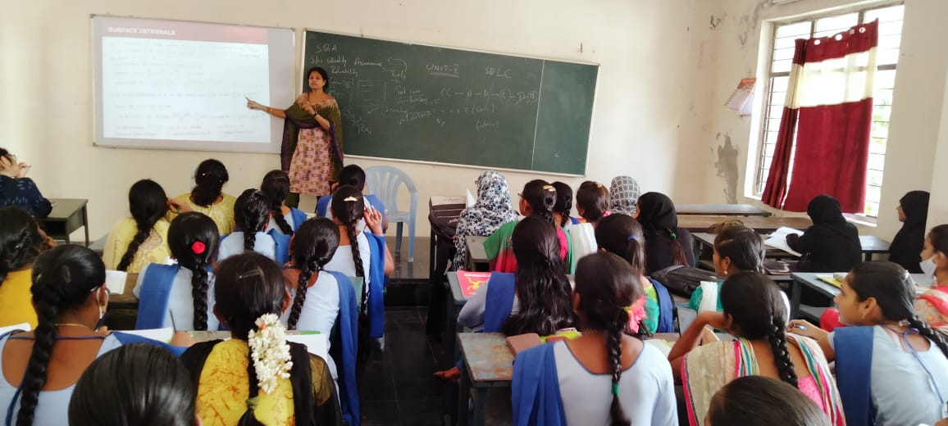
Physics | NAME :Dr.M.Padmavathi  DESIGNATION : Lecturer in Physics  TOPIC : Field Effect Transistor  COs/LEARNING OBJECTIVES :Construction &Working of FET  TEACHING METHODS ADOPTED :Interactive teaching method [ PPT]  GROUP/SEMESTER :III B.Sc – VI SEM  APPLICATION :In circuit designing and manufacturing of electronic devices. | 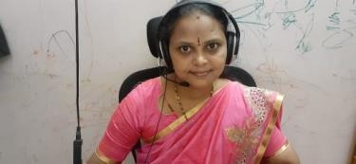
 | NAME :Dr.M.V.Ramanaiah  DESIGNATION : Lecturer in Physics  TOPIC : Operational Amplifiers - Basics  Cos/LEARNING OBJECTIVES :Block diagrams and Pin Configurations TEACHING METHODS ADOPTED :Interactive teaching method [ PPT]  GROUP/SEMESTER :III B. Sc – VI SEM ( 2020 Batch)  APPLICATIONS :To construct and Analyze the simple mathematical operations like addition, subtraction, division, integration and differentiation. | 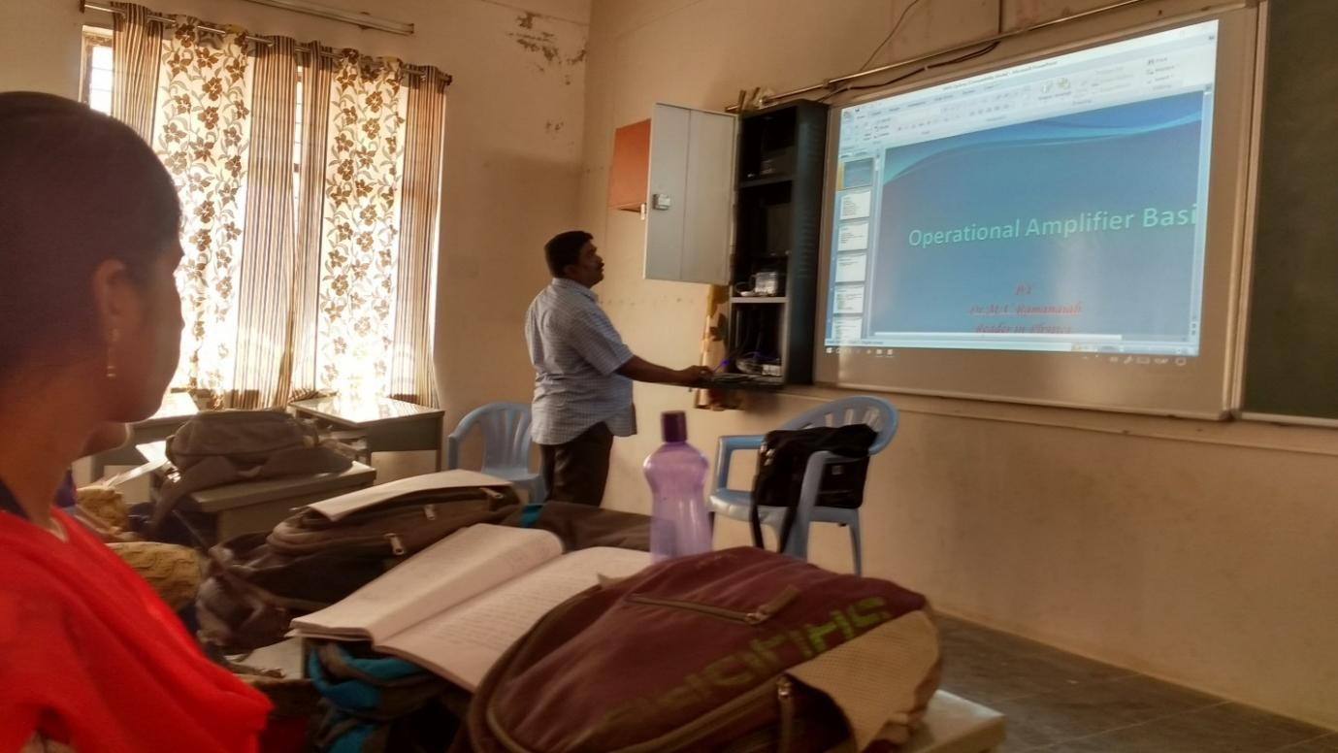
 | NAME : M. Veerabhadraiah  DESIGNATION : Lecturer in Political Science  TOPIC : BRICS  Cos/LEARNING OBJECTIVES : To know the Composition , Objectives & Functions of the BRICS  TEACHING METHODS ADOPTED : Demonstration Method [ PPT]  GROUP/SEMESTER : III BA HEP {TM) – VI sem APPLICATION : It is essential for the development of  International Peace & Cooperation. | 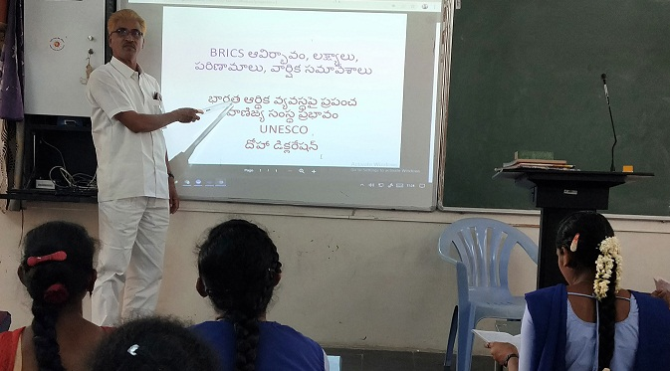
 | NAME :Dr. P.V.SUBBA REDDY  DESIGNATION : Lecturer in Political Science  TOPIC : Parliamentary form of Government  Cos/LEARNING OBJECTIVES : To know the Composition , Objectives, Functions, Merits & Demerits of the Parliamentary form of Government  TEACHING METHODS ADOPTED : Demonstration Method [ PPT]  GROUP/SEMESTER : II BA HEP {TM) – III SEM  APPLICATION : It helps the students in future for the Formation of a responsible Government. | 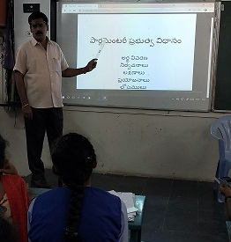
omputer Science | I.NAME: A.Haritha, Lecturer in Computer Science,  II SUBJECT:. DS using java  III. Course Outcomes:  - To develop skills to design and analyze simple linear and non linear data structures.  - Design and implement Data structures such as linked list, stack, queue and tree by using C as the programming language and using static or dynamic implementations.  - Represent and manipulate data using non linear data structures like trees and graphs  - Assessment by conducting quiz using plickers.  IV.Interactive Teaching/Demonstrative Teaching/Participative Teaching Methods Adopted.  V. CLASS:B.Sc MSCS IV semester | 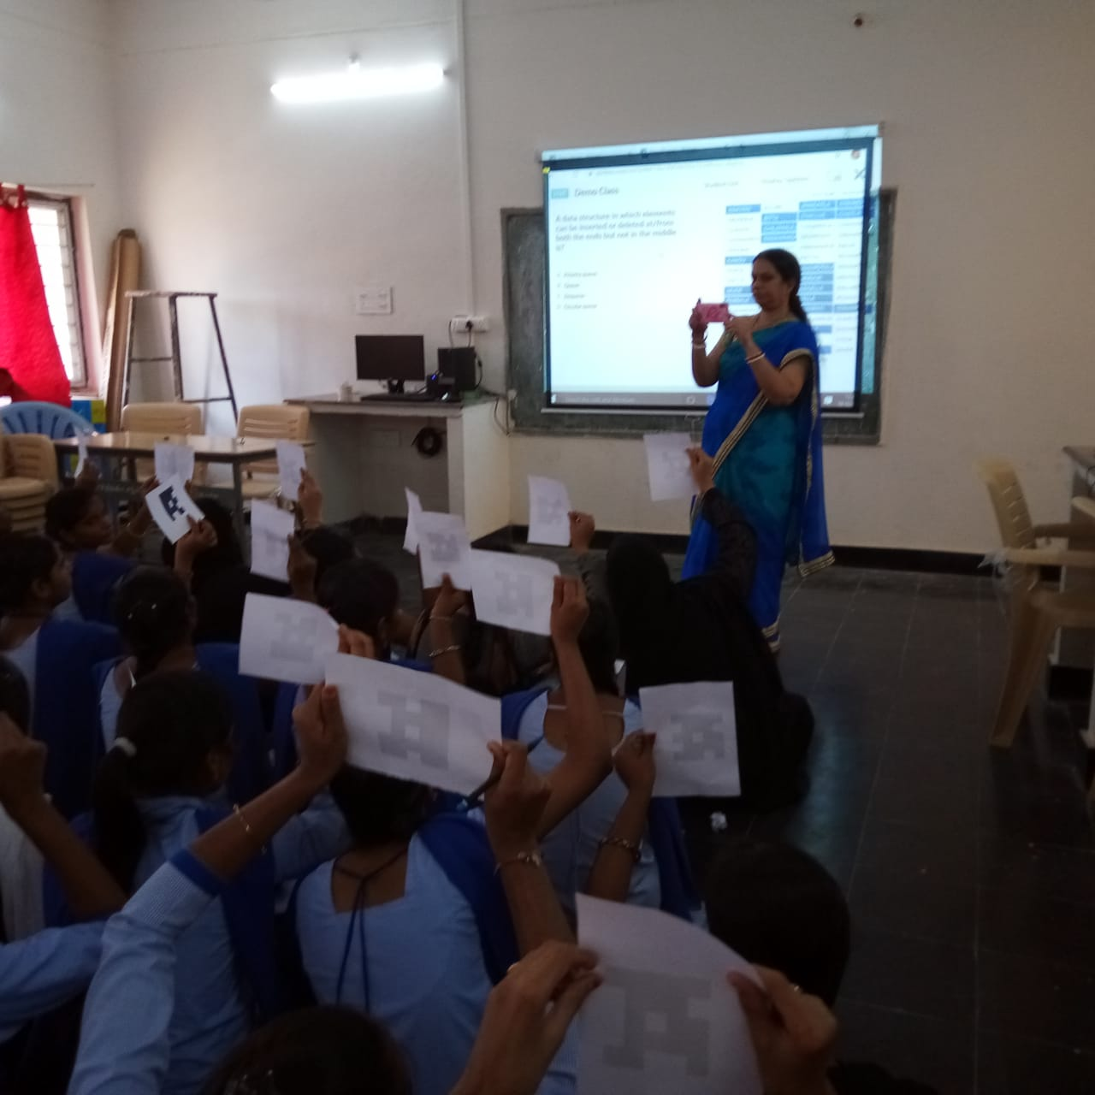
 | I. NAME:C V Krishnaveni, Lecturer in Computer Science,  II.SUBJECT: Web Technologies  III. Course Outcomes:  1. To understand the web architecture and web services.  2.To practice the latest web technologies and tools by conducting experiments.  3.To design interactive web pages using HTML and Style sheets.  4.To study the framework and building blocks of .NET Integrated Development Environment.  5.To provide solutions by identifying and formulating IT related problems.  IV. Interactive Teaching/Demonstrative Teaching/Participative Teaching Methods Adopted.  V.. B.Sc MPCS VI semester 6. Creating Web Pages. | 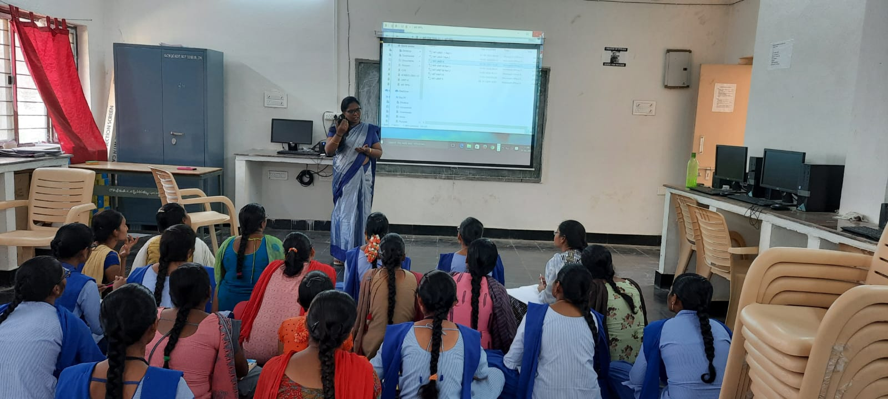
ECONOMICS | NAME :Dr.G.VijayaLaskhmiDevvi  DESIGNATION : Lecturer in Economics  TOPIC : Demand Analysis  Cos/LEARNING OBJECTIVES: To understand the Demand Price relation  TEACHING METHODS ADOPTED :Participative learning [ PPT]  GROUP/SEMESTER :I B.A (EM) – SEM-I  APPLICATION : To study the Demand function | 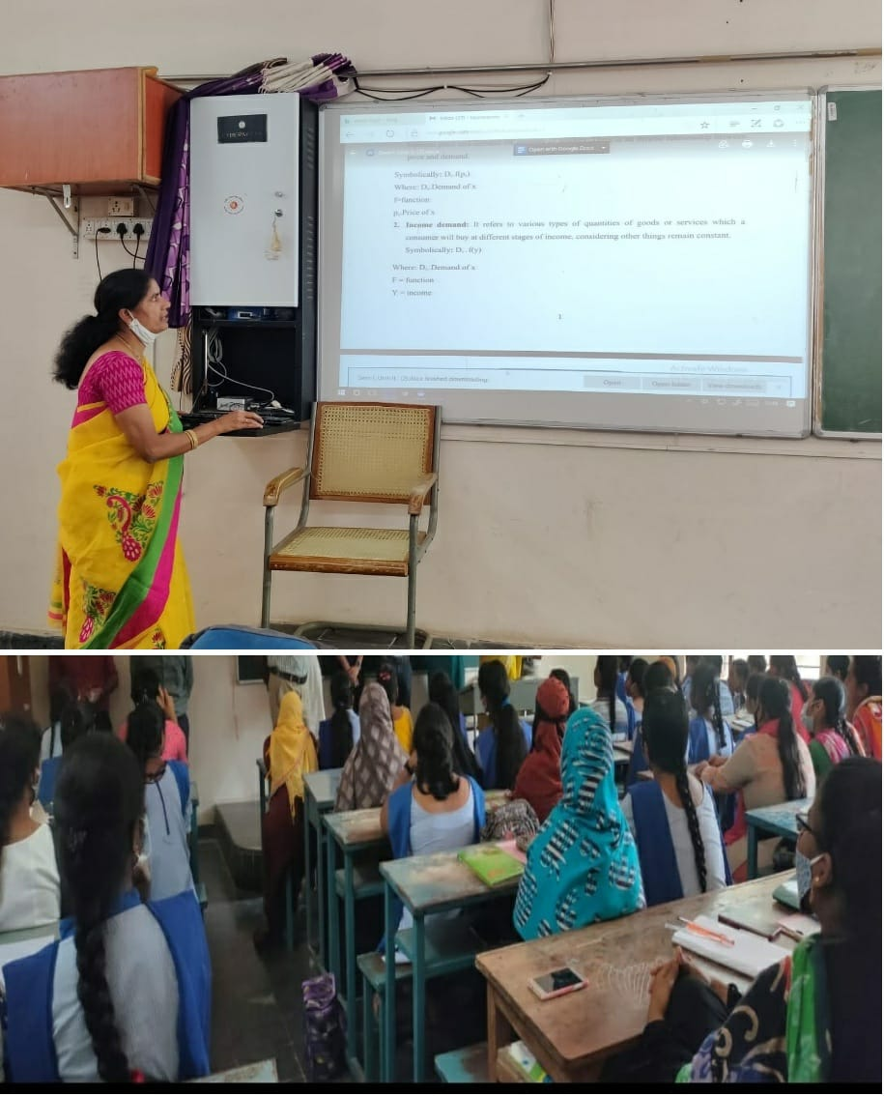.
 | NAME :T.Srinivasulu Reddy  DESIGNATION : Lecturer in Economics  TOPIC: Circular flow of Income  Cos/LEARNING OBJECTIVES : To learn about the income circulation  TEACHING METHODS ADOPTED :Participative learning( PPT)  GROUP/SEMESTER :I B.A (EM) – I SEM  APPLICATION :once expenditure is anotherincome | 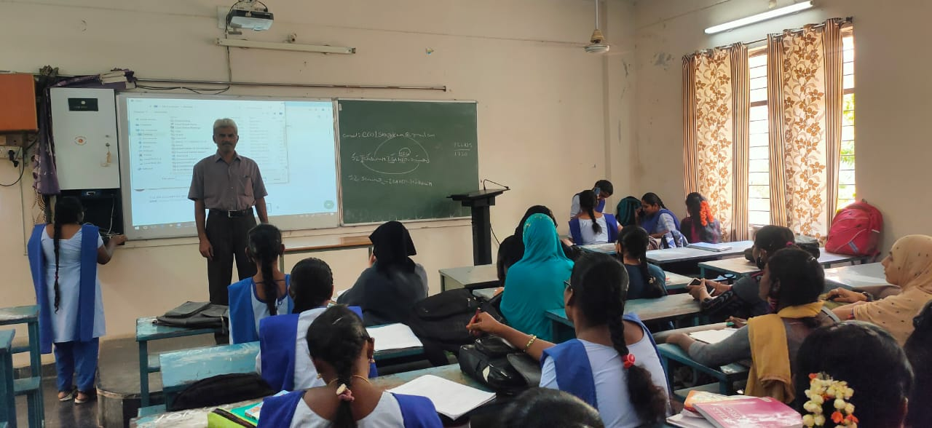
Electronics | NAME: J. Ashavijayalakshmi  DESIGNATION: Guest faculty in Electronics  TOPIC : Interface keyboard  Cos/LEARNING OBJECTIVES: To interface keyboard with 8051 Microcontroller  TEACHING METHODS ADOPTED: Participative learning method [PPT]  GROUP/SEMESTER: III B.Sc – VI SEM  APPLICATION: For interfacing keyboard to processor. | 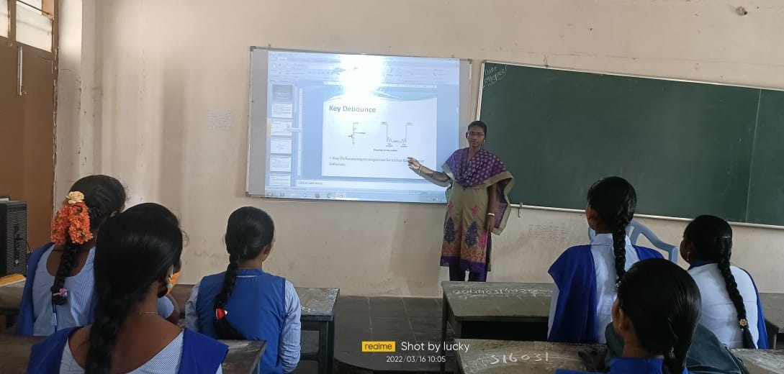
 | NAME : G.Rajani  DESIGNATION : Guest faculty in Electronics  TOPIC : single chip controllers & LCD Timer  alarm  Cos/LEARNING OBJECTIVES :Data flow chart & basic operations in  algorithm  TEACHING METHODS ADOPTED :Participative learning method [ PPT]  GROUP/SEMESTER : III B.Sc – VI SEM  APPLICATION :Light &temperature sensing Controlling devices. | 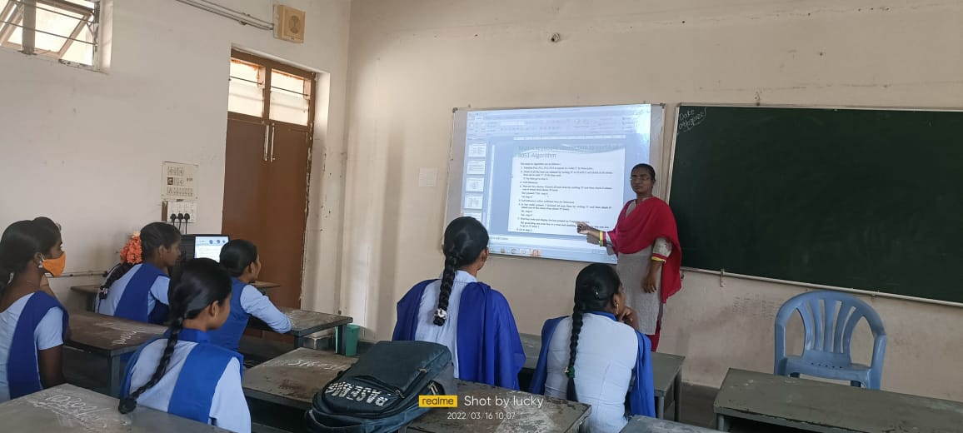
Microbiology | NAME : Dr.B.PRIYADARSINI  DESIGNATION :Lecturer in Microbiology  TOPIC : Viral Disease- Swine Flu  Cos/LEARNING OBJECTIVES : To learn about the Global, Historical  impact and transmission of this disease.  TEACHING METHODS ADOPTED :Participative learning [ PPT]  GROUP/SEMESTER : III BMC-V- SEM  APPLICATION : Knowledge and Awareness regarding  this disease. | 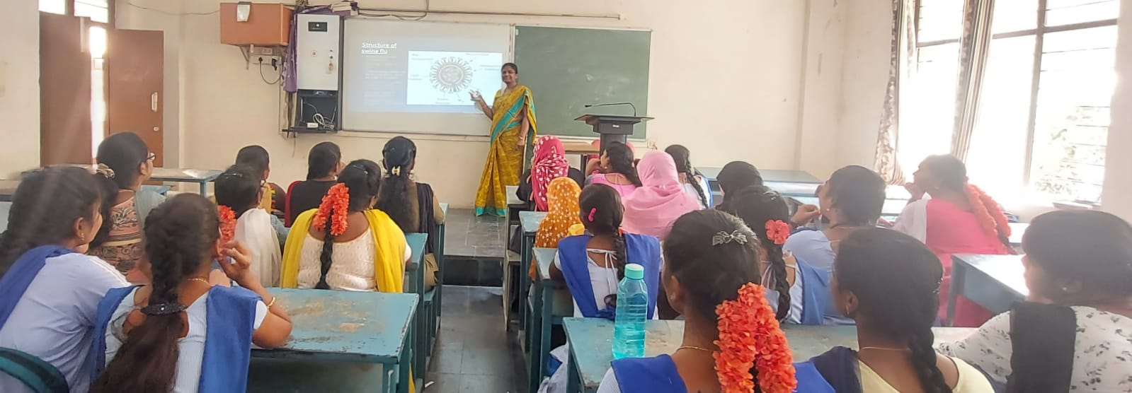
URDU | NAME :Dr.Shaeeya Begum  DESIGNATION : Lecturer in Urdu  TOPIC : RubayikaTaruff  Cos/LEARNING OBJECTIVES : To TEACHING METHODS ADOPTED :Participative learning [ PPT]  GROUP/SEMESTER :IIB.Sc/B.Com/BA{EM/UM) – III SEM  Poetry and Tecnics of writing | 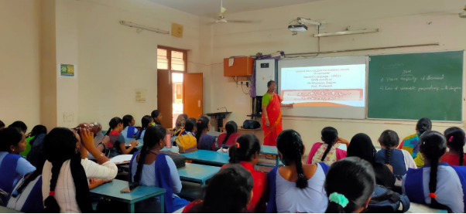
 | NAME :P.sartaj Begum  DESIGNATION : Lecturer in Urdu  TOPIC : Rubiyakaagaz o Irtakha  Cos/LEARNING OBJECTIVES : To learn about the Rubiyath  TEACHING METHODS ADOPTED :Interaction method [ PPT]  GROUP/SEMESTER :III B.A{UM) – VI SEM  APPLICATION : Urdu poetry -Rubayi - agaz o Irtakha etc. | 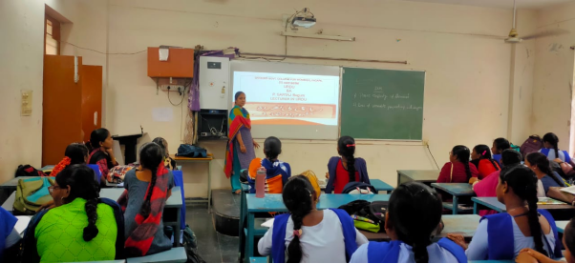
Hindi | NAME :D.Mahajabeen  DESIGNATION : Lecturer in Hindi  TOPIC : MunshiPrame Chand  Cos/LEARNING OBJECTIVES : TEACHING METHODS ADOPTED :Interaction method [ PPT]  To learn about the GROUP/SEMESTER :II B.A/B.Sc/B.com{EM/TM) – III SEM  Hindi MunshiPrem Chand | 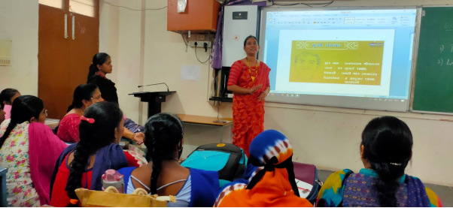
Tourism | NAME : Mrs. A. Aruna  DESIGNATION :Guest Lecturer in Tourism  TOPIC :Dance Forms  Cos/LEARNING OBJECTIVES :To create the students about the dance forms  TEACHING METHODS ADOPTED :Interaction Method [PPT]  GROUP/SEMESTER : III B.A{TTM) – VI SEM  APPLICATION :Stage performance | 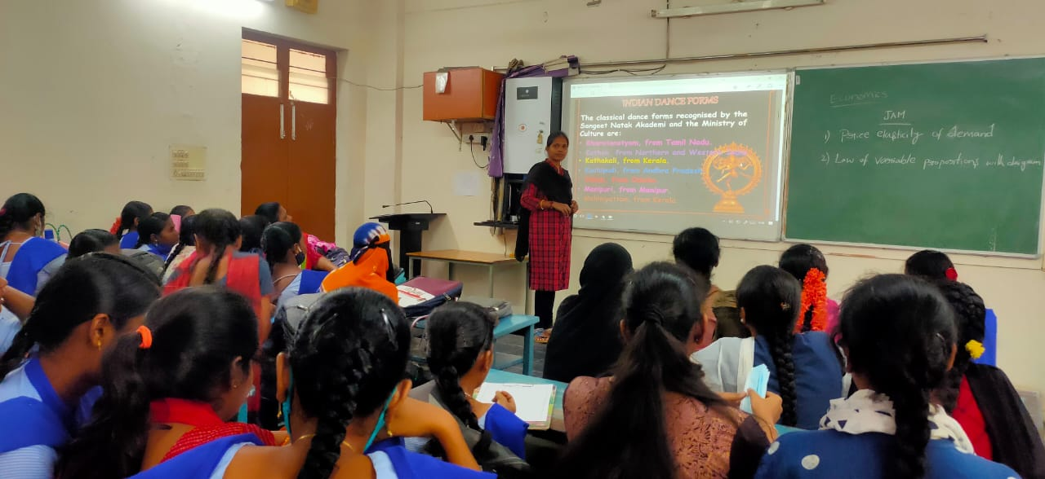
Chemistry | Name of the Lecturer: L.SUDHEERA  Designation: Lecturer in Chemistry  Topic : IR Spectroscopy  Course Outcome/Learning Objective To analyze the spectroscopic techniques to determine the organic molecules  Teaching Methods Adopted  Interactive Teaching using PowerPoint presentation  Group/Semester  II Bt.Z.C/Semester-III | 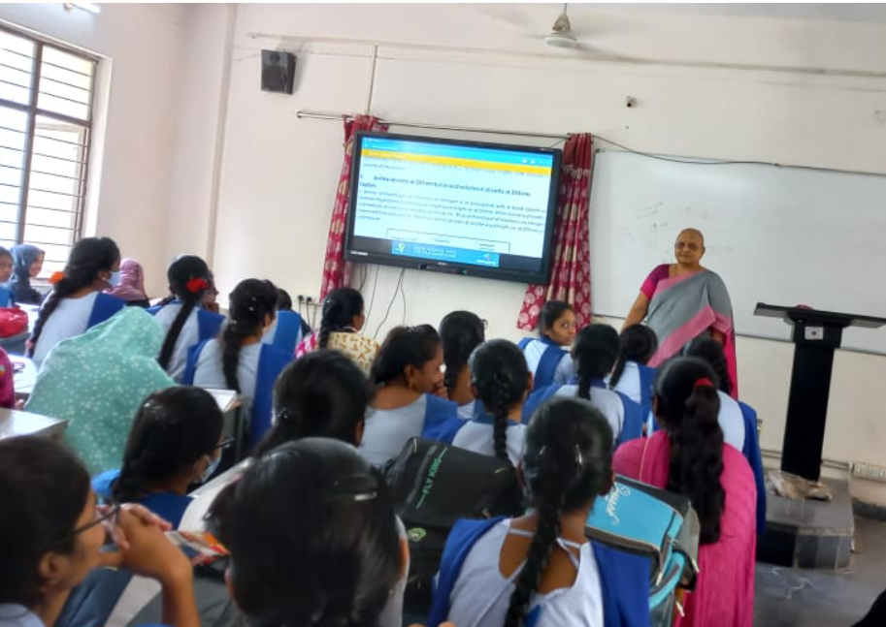
 | Name of the Lecturer D. Winnie Teja  Designation Lecturer in Chemistry  Course Outcome/Learning Objective  To learn about the e  Teaching Methods Adopted  Interactive Teaching using PowerPoint presentation  Group/Semester III B.Z.C & III M.P.C/Semester-V  Application determining the rate of a chemical reaction and also plays a major role in calculating the energy of activation | 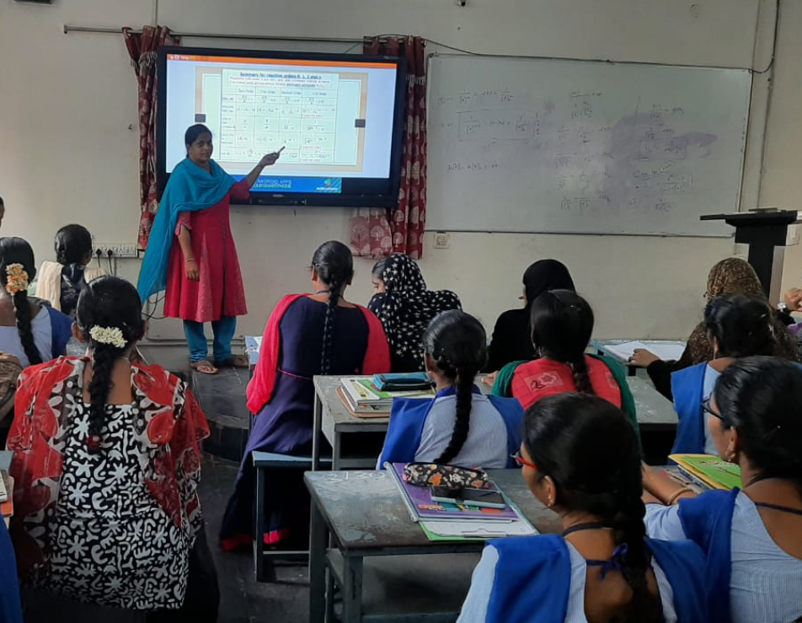  .
Statistics | Name: N.Raghvendra  DESIGNATION Lecturer in Statistics  TOPIC Two Variable Regression Model  Cos/LEARNING OBJECTIVES to explain variability in dependent variable by means of one or more of independent or control variables TEACHING METHODS ADOPTED Interaction method [PPT]  GROUP/SEMESTER III BSc  APPLICATION Regression analysis is used to estimate the relationship between a dependent variable and one or more independent variables  Field Marketing Research, etc.. | 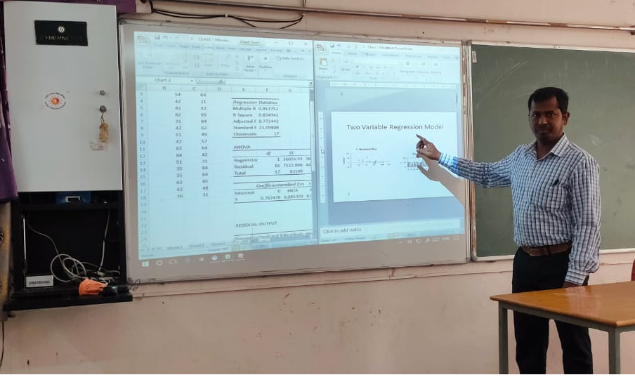
English | Name of the Lecturer Smt P. Sujatha  Designation Lecturer in English  Course Outcome/Learning Objective  SWOT analysis  Teaching Methods Adopted  Interactive Teaching using PowerPoint presentation  Group/Semester I BA HEP  Application : Assesing themselves to know about their strength and weakness. | 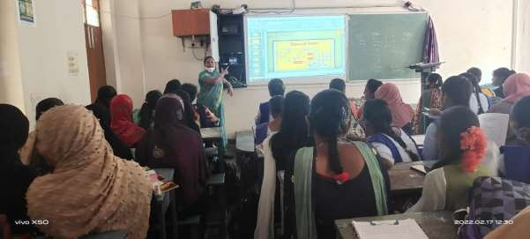
TELUGU | NAME : O.Geetha  DESIGNATION : Lecturer in Telugu  TOPIC : సీతా రావణ సంవాదం  Cos/LEARNING OBJECTIVES : సప్త వ్యసనాలు వల్ల కలిగే నష్టాలు  TEACHING METHODS ADOPTED : Participative learning [ PPT] GROUP/SEMESTER : I B.Sc MECS {EM) – I SEM  APPLICATION : ప్రాచీన సాహిత్య విలువలు.యువతకు ఆదర్శ పాత్రలు రామాయణం లో అనేకం ఉన్నాయి.అందుకే యవ్వనం లో రామాయణం చదవాలి అని చెప్పారు. | 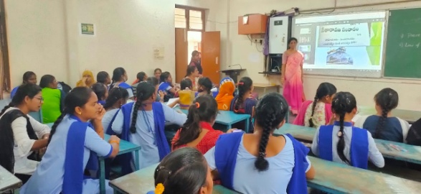
 | NAME : J. Ravindra babu  DESIGNATION Lecturer in History  TOPIC second World war Cos/LEARNING OBJECTIVES  About europe people TEACHING METHODS ADOPTED Participative learning [ PPT] GROUP/SEMESTER III BA. Hep Em/Tm  APPLICATION : To know about the war effect | 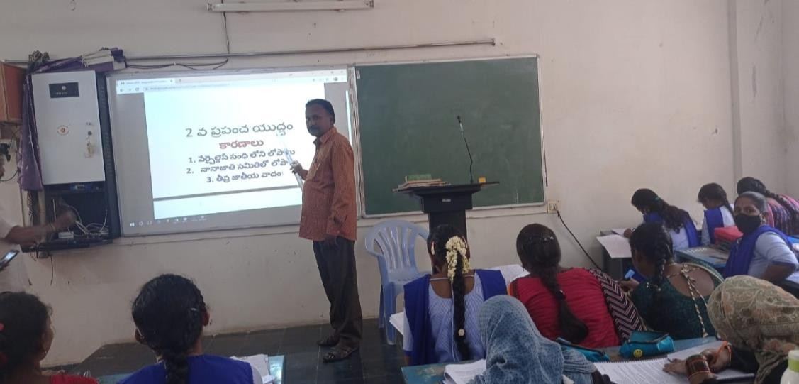

S.K.R. & S.K.R. Government College for Women (A) is bestowed with 13 ICT (Information and Communication Technology) enabled classrooms including 2 Virtual class rooms and 3 digital class rooms for effective teaching-learning. These Classrooms are fully equipped with Computers and LCD projectors. All the departments are well equipped with latest computers, color printers cum scanners which have Wi-Fi connectivity. This enables the teachers to be connected with the students offline as well as online.
In addition to chalk and talk method of teaching, our faculty members are well experienced in using the IT enabled learning tools such as PPT, Video clippings , Audio system, online resources,to expose the students for advanced knowledge and practical learning. Blended teaching-learning is adopted by the teachers, where they use traditional classroom teaching methods together with the use of online learning for the same students studying the same content in the same course.
The faculty use the following ICT enabled tools and online resources to enhance the quality of teaching-learning.
- Google classroom is used to manage and post course related information- learning material, quizzes, lab submissions and evaluations, assignments, etc.
- As the UGC has banned dissections virtual demonstrations and dissections are used by teachers to enable the students to gain a better understanding. Lab manuals and procedures are mailed to students well in advance before the experiment is performed.
- To improve the learning skills of the students, quizzes and assignments are conducted using online assessment tools like Testmoz, Socrative, Google forms, Mentimeter & kahoot, a game-based assessment tool. All these can be easily accessed by students in their smart phones and the teachers can readily obtain the evaluative report.
- Digital Plickers are also used to collect real-time formative assessment data without the need for student devices.
- Even Covid-19 could not stop the teaching, learning & evaluation procedure of the college.
- During Covid pandemic, online teaching was effectively carried out by all the teaching fraternity by creating programme-wise student’s WhatsApp groups. Sharing meeting links, study materials, online teaching recorded videos.
- Online platforms like Cisco Webex, Zoom, Google meet were effectively used to teach the curriculum to the students with interaction.
- Auditorium- is digitally equipped with mike, projector, cameras and computer system to organise various awareness programs, student induction programs for students.
- Indirect Assessment is done by collecting feed-back from the students on the curriculum and teaching-learning environment on every course at semester end.
- YouTube is also used as a learning platform. Course & Topic related videos are shared with students in the WhatsApp groups for clear understanding. Our lectures are running YouTube channels which are subscribed by our students. Teachers upload the videos and online lessons which can be watched by students at their convenience.
- Our college faculty and students are registered in the UGC N-LIST-INFLBNET Centre. The N-LIST Project provides access to e-resources to students and faculty from colleges and other beneficiary institutions through server(s) installed at the INFLIBNET Centre. Our students have access to e-resources and they download articles required by them directly from the publisher's website.
- Our Commissioner of Collegiate Education, Andhra Pradesh selected faculty and trained our teachers for developing e-content and LMS videos. Teachers using OBS software, online editing tools like open shot video editor and Audacity, developed videos and e-content and also uploaded them in APCCE LMS website. These videos can be accessed by students from anywhere and at any time and they can easily understand the subject with quality information.
- APSCHE also selected and trained teachers in developing Podcasts. Podcast is a digital audio file made available on the internet for downloading to a personal audio player. Teachers can record and share podcast to provide additional and revision material to the students. Podcasts can immensely benefit to auditory learners in their learning. Online teaching and learning process can be enriched with podcasts related to the course. APSCHE LMS portal is available for students.
- The research journals and e-books are available on online library to our faculty and students.
- All the departments regularly conduct webinars, workshops and guest lectures, on the new developments in the core subjects for effective teaching and learning by Industry experts and Alumni on Zoom platforms.
- Our students and faculty also have access to Swayam Prabha channels, where the students are enrolled in their course related channels to understand the subjects better and in depth and also helpful to them in appearing for competitive examinations.
- Our teachers also use blogsto publish assignments, resources, and keep students and even parents up to date on class events, due dates, and content being covered. Blogging is a great way toencourage students to express their ideas, be creative, develop confidence in writing, to communicate and collaborate with peers and the teachers.

.

